# Economics

## Elasticity

### Price elasticity of demand

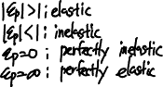

### Income elasticity of demand

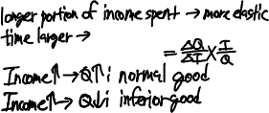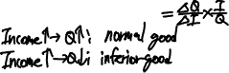

### Cross-price elasticity of demand



### Substitute & Income effect

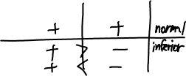

### Factors of production

* Land, labor, capital, materials

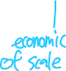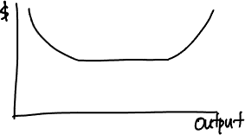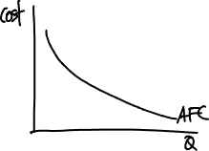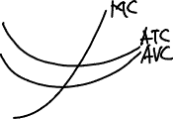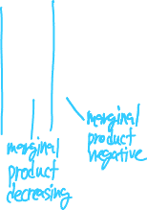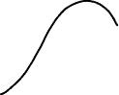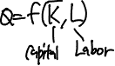

## Characteristics of market structure

|  |  |  |  |  |
| --- | --- | --- | --- | --- |
|  | Perfect competition | Monopolistic competition | Oligopoly | Monopoly |
| # of sellers | Many firms | Many firms | Few firms | Single firm |
| Barriers to entry | Very low | low | high | Very high |
| Nature of substitute products | Very good substitutes | Good substitutes but differentiated | Very good substitutes or differentiated | No good substitutes |
| Nature of competition | Price only | Price, marketing | Price, marketing, features | advertising |
| Pricing power | none | some | Sone to significant | Significant |

## Perfect competition

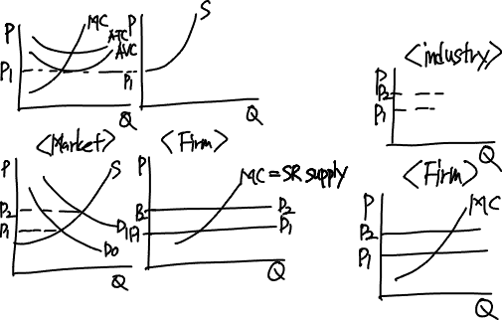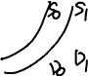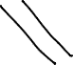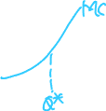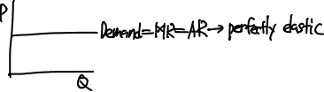

## Monopolistic competition

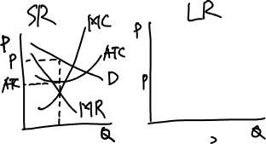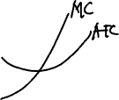

## Oligopoly

1. Kinked demand curve model
   1. An increase in a firm’s product price will not be followed by its competitors but a decrease in price will.
   2. Kink is the profit-maximizing level of output
2. Cournot duopoly model
   1. Two firms with identical marginal cost curves each choose their preferred selling price based on the price the other firm chose in the previous period.
3. Nash equilibrium model (prisoner’s dilemma)
   1. When the choices of all firms are such that there is no other choice that makes any firm better off (increases profits or decreases losses)
4. Stackelberg dominant firm model
   1. One firm is the ‘leader’ and chooses its price first, and the other firm chooses a price based on the leader’s price. In equilibrium, the leader charges a higher price and receives a greater proportion of the firms’ total profits.
5. Dominant firm model
   1. Demand curve is more elastic

In general, collusive agreements to increase price in an oligopoly market will be more successful (have less cheating) when

* There are fewer firms
* Products are more similar (less differentiated)
* Cost structures are more similar
* Purchases are relatively small and frequent
* Retaliation by other firms for cheating is more certain and more severe
* There is less actual or potential competition from firms outside the cartel

## Monopoly

1. Single price
2. Price discrimination
   1. For price discrimination to work, the seller must
      1. Face a downward-sloping demand curve
      2. Have at least two identifiable groups of customers with different price elasticities of demand for the product
      3. Be able to prevent the customers paying the lower price from reselling the product to the customers paying the higher price.

Monopoly creates a deadweight loss relative to perfect competition because monopolies produce a quantity that does not maximize the sum of consumer surplus and producer surplus. A further loss of efficiency results from rent seeking when producers spend time and resources to try to acquire or establish a monopoly.

## Natural monopoly

1. Average cost pricing
   1. price = ATC
   2. increases output and decrease price
   3. increase social welfare – allocative efficiency
2. Marginal cost pricing
   1. Government subsidy
3. To sell the monopoly right to the highest bidder

## Supply functions

* Only under perfect competition, there is SR supply curve, same as its MC curve

## Concentration measure

1. N-firm concentration ratio
   1. Limitation – relatively insensitive to mergers of two firms with large market shares
2. Herfindahl-Hirschman Index (HHI)

A limitation of both is that barriers to entry are not considered in either case.

## Favor of trade restrictions supported by economists

* National defense industries should be protected.
* Infant industries should be protected.
* Trade with low-wage countries does not itself depress wage rates since productivity must be considered.

For a perfectly competitive firm, maximum profit occurs at the output level where MR = MC. And, since the demand curve faced by each firm in perfect competition is horizontal, MR is equal to price.

All firms will continue to expand production until MR = MC.

## Under perfectly competitive industry, SR supply curve

* SR supply curve for a firm is its MC curve above the AVC curve.
* SR supply curve of the market is the sum of the supply curves for all firms in the industry.

## Business cycle

* Peak
  + GDP growth rate decrease
  + Unemployment rate decreases but hiring slow
  + Consumer spending and business investment grow at slower rates
  + Inflation rate increases

## Money neutrality

MV = YP

Real variables (V, Y) are not affected by monetary variables (M, P).

## Central bank

* Target independent – define how inflation is computed, target inflation level, horizon.
* Operationally independent – independently determine policy rate.

## Current account

* Merchandise and service
* Income receipt – interest, dividend
* Unilateral transfers

## Capital account

* Capital transfer
* Sales and purchases of non-financial assets
  + Natural resources and intangible assets, such as patents, copyrights, trademarks, franchises, and leases.

## Financial account

* Government-owned assets abroad
* Foreign-owned assets in the country

(S – I) = (G – T) + (X – M)

## Fiscal multiplier

## Production function

Labor and capital

## Monopoly, oligopoly

* Positive economic profits in LR

## Wealth effect

* At full employment, weaker currency has lower purchasing power

## Structural budget deficit

* The structural budget deficit occur based on current policies if the economy were at full employment.

## Ricardian model of trade

* Only one factor of production – labor

## Heckscher-Ohlin model

* Redistribution of wealth within each country between labor and the owners of capital.

## National income

National income = compensation of employees (wages and benefits)

+ corporate and government enterprise profits before taxes

+ interest income

+ unincorporated business net income (business owner’s incomes)

+ rent

+ indirect business taxes

– subsidies (taxes and subsidies that are included in final prices)

## GDP

GDP = national income + capital consumption allowance + statistical discrepancy (Income approach)

GDP = C + I + G + (X – M)

## GDP deflator

GDP deflator = nominal GDP / real GDP * 100

## Forward exchange rate

## Real exchange rate

## CPI

## Fiscal policy and monetary policy

|  |  |  |
| --- | --- | --- |
|  | AD | Interest rate |
| Expansionary fiscal & Expansionary monetary | up | Down |
| Expansionary fiscal & Contractionary monetary | up | Up |
| Contractionary fiscal & Expansionary monetary | down | Down |
| Contractionary fiscal & Contractionary monetary | down | up |

## Marshall-Lerner condition

## Real business cycle

## Natural monopoly

## Neutral interest rate

## Veblen good

* Price up -> more valuable

## Shift in AD

* Expansionary monetary policy / fiscal policy
* High capacity utilization
* Consumer expectations of future income
* Business expectations
* Increase in consumers’ wealth
* Exchange rate
* Global economic growth

## Shift in SRAS

* Labor productivity
* Input price
* Expectations of future output prices
* Taxes and government subsidies
* Exchange rates

## Shift in LRAS

* Increase in the supply and quality of labor
* Increase in the supply of natural resources
* Increase in the sock of physical capital

## Growth in potential GDP

Growth in potential GDP = growth in technology + WL * growth in labor + WC * growth in capital

## Monopolist

* Price searcher – imperfect information about the demand curve

Increase of Expected future incomes and increase of money supply -> increase AD